**Network Protocols and Security(23EC2210A)**

**Submitted by of Section 7**

K. Shourya – 2320090003

P. Yashwanth – 2320090012

M. Sanjeev – 2320090033

**Under the guidance of**

**f**

**KLH University Hyderabad**

**Bowrampet, Bachupally-500090, Telangana, India.**

**Abstract for the Project on Web Phishing using Mass Mailer Attack**

**Problem Statement:**  
Web phishing, particularly through mass mailer attacks, is one of the most effective techniques used by cybercriminals to deceive individuals into divulging sensitive information, such as login credentials or financial data. The growing sophistication of phishing methods, combined with the ease of deploying mass mailer campaigns, makes it a critical threat to personal and organizational security. This project aims to explore the implementation of phishing attacks using mass mailers, with a focus on simulating and analysing phishing strategies, detection mechanisms, and effective security countermeasures.

**Objectives:**

* Simulate a phishing campaign using a mass mailer attack to understand the techniques used by attackers.
* Identify and analyse vulnerabilities in human behaviour and network security that enable successful phishing attacks.
* Explore and demonstrate methods to detect phishing attacks, including recognizing suspicious URLs, email headers, and malicious attachments.
* Present security solutions to prevent and mitigate phishing attacks, including multi-factor authentication (MFA), secure email gateways, and user education.
* Develop a comprehensive understanding of offensive and defensive cybersecurity practices related to phishing.

**Scope:**  
This project will focus specifically on web-based phishing techniques executed via mass mailer attacks. The boundaries of the study include:

* Implementation of mass mailer tools to simulate phishing emails.
* Study of social engineering techniques for targeting victims.
* Analysis of email spoofing, phishing detection, and countermeasure techniques.
* Focus on the security mechanisms that organizations can implement to defend against phishing, while not covering areas like other cyber-attacks (e.g., ransomware, DDoS).

**Feasibility:**

* **Timeline:** The project is expected to be completed over the course of 2 months, with specific milestones in simulation, analysis, and report generation.
* **Resources:** Access to cybersecurity simulation tools, mass mailer software, email servers for testing, and network analysis tools.
* **Tools:** Kali Linux for penetration testing, Cisco Packet Tracer for network analysis, Python for scripting automated phishing emails, and Wireshark for monitoring phishing-related network traffic.

**System Architecture:**

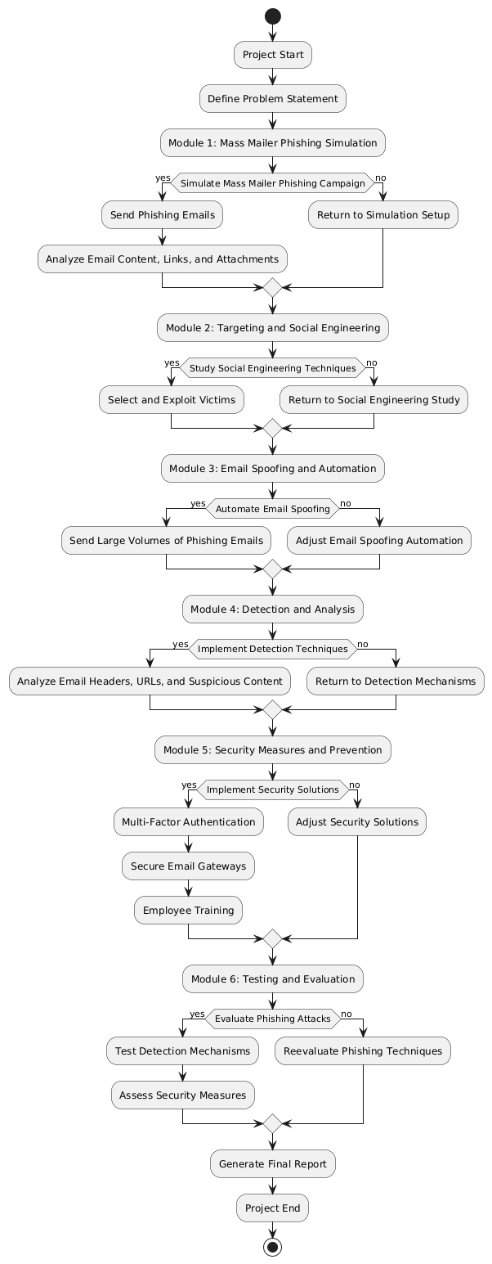

**Technology Stack:**

* **Operating System:** Kali Linux for penetration testing and phishing simulation.
* **Tools:**
  + **Email Spoofing Tools:** Social Engineering Toolkit (SET), Python scripts for mass mailers.
  + **Detection Tools:** Wireshark, Spam Assassin for detecting phishing emails.
  + **Automation Tools:** Python, PowerShell scripts for email automation.
  + **Security Tools:** Multi-factor authentication solutions, spam filters, secure email gateways.
  + **Network Analysis:** Cisco Packet Tracer for understanding network vulnerabilities and monitoring.
* **Languages:** Python for automation and scripting, Bash for Linux-based tasks.

**Modules:**  
The project will be divided into the following modules:

1. **Mass Mailer Phishing Simulation:**
   * Implement a mass mailer to send phishing emails to simulate an attack.
   * Analyze email content, links, and attachments used to trick users.
2. **Targeting and Social Engineering:**
   * Study how attackers select and exploit victims using social engineering techniques.
3. **Email Spoofing and Automation:**
   * Automate email spoofing to send large volumes of phishing emails.
4. **Detection and Analysis:**
   * Implement detection techniques to identify phishing attempts through email headers, URLs, and suspicious content.
5. **Security Measures and Prevention:**
   * Implement solutions such as multi-factor authentication (MFA), secure email gateways, and employee training to defend against phishing.
6. **Testing and Evaluation:**
   * Evaluate the effectiveness of simulated phishing attacks and the robustness of detection and security measures.